Name – Akshat Bhargava

Roll no – 22563

ANN – SL2

Prac 13

Code –

import tensorflow as tf

from tensorflow import keras

from tensorflow.keras import layers

# Load the MNIST dataset, a collection of handwritten digits

mnist = keras.datasets.mnist

(x_train, y_train), (x_test, y_test) = mnist.load_data()

# Normalize pixel values to be in the range [0, 1]

x_train, x_test = x_train / 255.0, x_test / 255.0

# Build the neural network model

model = keras.models.Sequential([

layers.Flatten(input_shape=(28, 28)),

layers.Dense(128, activation='relu'),

layers.Dropout(0.2),

layers.Dense(10, activation='softmax')

])

# Compile the model

model.compile(optimizer='adam',

loss='sparse_categorical_crossentropy',

metrics=['accuracy'])

# Train the model

model.fit(x_train, y_train, epochs=5)

# Evaluate the model on the test data

test_loss, test_acc = model.evaluate(x_test, y_test, verbose=2)

print("\nTest accuracy:", test_acc)

# Save the model

model.save("handwritten_digit_recognition_model.h5")

import tensorflow as tf

from tensorflow.keras.models import load_model

import numpy as np

import matplotlib.pyplot as plt

# Load the saved model

model = load_model("handwritten_digit_recognition_model.h5")

# Load an example image (you can replace this with your own image)

image_path = "number.jpg"

image = tf.keras.preprocessing.image.load_img(image_path,

color_mode="grayscale",

target_size=(28, 28))

input_data = tf.keras.preprocessing.image.img_to_array(image)

input_data = input_data / 255.0 # Normalize the pixel values

# Make a prediction on the input data

prediction = model.predict(np.array([input_data]))

# Get the predicted digit (the class with the highest probability)

predicted_digit = np.argmax(prediction)

# Display the image and the predicted digit

plt.imshow(input_data.reshape(28, 28), cmap="binary")

plt.show()

Input Image –

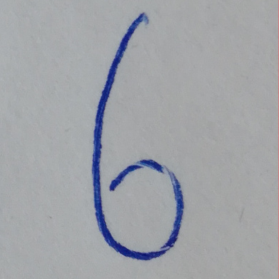

Output –

